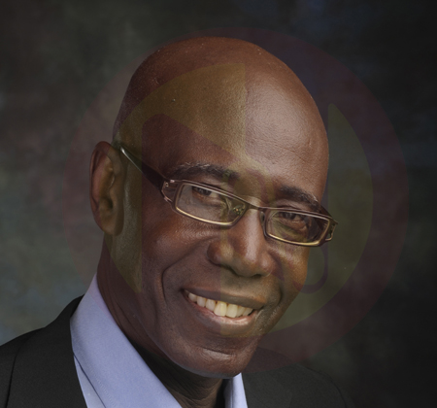
Haynesley Griffith
Founder & Chief Executive Officer

Born in the picturesque island of Barbados, Reverend Haynesley Griffith is the founder and Chief Executive Officer of the Barbados based Family Heartbeat International Network Inc., a counseling ministry that seeks to empower families to fulfill their God-given role in the home and in the wider society.

This ordained minister with The Wesleyan Holiness Church and trained counselor, has a wide range of highly specialised skills, experience, and sound knowledge, which he has acquired and applied in various capacities as Counselor, Administrator, Teacher, Facilitator, Pastor, Journalist, Communicator, Critical Incident Stress Manager (CISM) and Motivational Speaker.

As a Licensed Professional Pastoral Therapist (LPPT), he brings with him over 25 years experience as a Family Life Counselor and over 30 years in the pastoral and other ministries where he has gained much success. Reverend Griffith’s training in psychology, crisis management and counseling was acquired from several institutions including Howard University, George Town Wesleyan University, Haggai Institute for Advanced Leadership Training, International Critical Incident Stress Foundation and many more.

Reverend Griffith’s leadership and counseling skills have been evident in many organisations. In 1983, he initiated and successfully run the Wesleyan Counseling Centre until 1989, and subsequently established another counseling unit, which he managed until December 1999. He also set up the in-house Stress Management programme for the Barbados Telephone Company Ltd. (BARTEL) and is currently the consultant counselor for Global Bank of Commerce Ltd. in Antigua.

Rev. Griffith, member of the American Association of Christian Therapists, now administers the very busy Family Heartbeat International Network Inc. counseling facility, and is producer and presenter of a very popular weekly radio programme, (Family Heartbeat Ministries Broadcast), that is aired on several radio stations throughout the Caribbean via the facilities of Caribbean Gospel Network (C.G.N.).

His counseling ministry takes him throughout the Caribbean and beyond, where he conducts family life training, counseling, workshops, seminars and conferences. He speaks at business places, churches, Para-church organisations, educational institutions and community groups, in various areas of group and individual counseling.

He is the author of the pre-marital counseling manual Securing The Foundation Of Marriage Before Building The Family.

For over two decades, he has worked very closely with young people as a Pastor, in camps, conventions, congresses, small groups, as well as on a one on one basis. He was awarded in 1996 for his work among the Caribbean Wesleyan Youth.

Rev. Griffith has a very good relationship with Dolores, his wife whom he married on March 03, 1979, and is the father of two married sons, Rollinson and Julian.
He loves meeting people, teaching, road tennis, swimming, walking and cooking.

